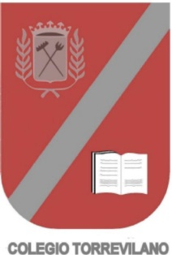
Frozen questionnaire
Choose the correct answer:
- What is the name of the princess?
- Anna
- Eva
- Eustaquia

- What is the name of the prince?
- Peter
- Hans
- Manolo

- What is the name of the snowman?
- Bolita
- Sven
- Olaf

- What color is Ana´s hair?
- Blond
- Pink
- Red

- What is the name of the kingdom where they live?
- Iceworld
- La la la
- Arindelle

- Which is the magic word?
- Please
- Thank you
- Spaghetti

